Subsidiary Mathematics
SENIOR Six term 3
TOPIC 1/2: Probability Distributions
Competency: The learner interprets binomial and normal distributions for analysis of data patterns and trends in real-world contexts.
Binomial distribution
A binomial distribution is a special type of a discrete random variable in which an experiment gives rise to only two outcomes either success or failure.
Conditions for binomial distribution
- The experiment has a finite (repeated) number of trials, n
- The trials are independent
- The outcome of each trial is either a success or a failure
- The probability, p of successful outcome is constant for all trials
If a discrete random variable X is the number of successful outcomes in n trials and satisfies the above conditions, then X follows a binomial distribution written as XB(n, p) or XBin (n, p)
Formula for Binomial distribution
- If XB(n, p), the probability of obtaining, r success in n trials P(X = r) where
P(X = r) =^{n}C_{r}p^{r}q^{n-r} for r = 0, 1, 2, 3, …,n where q = 1-p
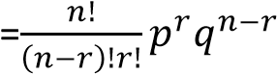
- E(X) = np
- Var(X) = npq where q = 1- p
- s.d =
√

Example 1
The random variable X is distributed B(7, 0.2). find
(i) P(X=3) (ii) P(1<X ≤ 4) (iii) P(X>1)
Solution
- n = 7, p= 0.2, q= 1- 0.2 = 0.8
P(X=3) = ⁷C₃ x 0.2³ x 0.8⁴
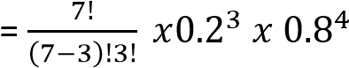
- P(1<X ≤ 4) = P(x=2) + P(X= 3) + P(X=4) 7 2 5 7 3 4 7 4 3
= C₂ x 0.2 x 0.8 + C₃ x 0.2 x 0.8 + C₄ x 0.2 x 0.8
= 0.275 + 0.115 + 0.029 = 0.419
- P(X>1) = 1- (P(X≤ 1) = 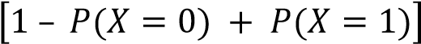
= 1 – [⁷C₀ x 0.2⁰ x 0.8⁷ +⁷C₁ x 0.2¹ x 0.8⁶]
=[1 – (0.210 + 0.367)
= 0.423

Example 2
At freedom city super market, 60% of the customers shop on Saturday. Find the probability that in a randomly selected sample of 10 customers
- Exactly 2 shop on Saturday n= 10, p = 0.6 q = 1- 0.6 = 0.4 P(X = 2) = ¹⁰C₂ x 0.6²x 0.4⁸ = 0.011
- More than 7 shop on Saturday
P(X > 7) = P(X = 8) + P(X = 9) + P(X = 10)
= ¹⁰C₈ x 0.6⁸x 0.4² + ¹⁰C₉ x 0.6⁹x 0.4¹ + ¹⁰C₁₀ x 0.6¹⁰x 0.4² = 0.121 + 0.040 + 0.006 = 0.167

Example 3
The probability that a marble drawn from a box is red is 0.4. If a sample of 6 marbles is taken, find the probability that it will contain;
- No red marble
n = 6, p= 0.4, q= 1 – 0.4 = 0.6
P(X = 0) = ⁶C₀ x 0.4⁰ x 0.6⁶ = 0.047
- P(X = 5 or 6) = P(X= 5) + P(X = 6) = ⁶C₅ x 0.4⁵ x 0.6¹ + ⁶C₆ x 0.4⁶ x 0.6⁰ = 0.037 + 0.004 = 0.041
- Less than half red marbles
P(X<3) = P(X = 0) + P(X = 1) + P(X = 2)
=⁶C₀ x 0.4⁰ x 0.6⁶ + ⁶C₁ x 0.4¹ x 0.6⁵ + ⁶C₂ x 0.4² x 0.6⁴
= 0.047 + 0.187 + 0.331 = 0.545

Example 4
A biased con is such that the chance of a head appearing upper most when tossed is twice of the tail appearing uppermost. If the coin is tossed 10 times. Find the probability that
- Exactly 6 heads will appear
P(H) + P(T) = 1 2x + x = 1 x = n = 10, p = 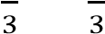; q=
P(X = 6) = 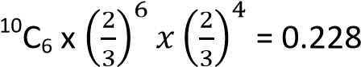
- P(5<X<8) = P(X = 6) + P(X = 7) = 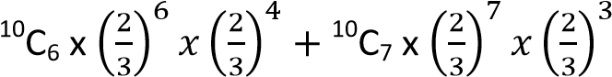
= 0.228 + 0.260 = 0.488

Example 5
A box contains a large number of pens. The probability that a pen is faulty is 0.1. How many pens would you need to select to be more than 95% certain of picking one faulty pen? Solution n? p= 0.1, q = 0.9
P(X≥ 1) = 1- P(X = 0)>0.95
= 1 - ^{n}C₀ x 0.1⁰ x 0.9^{n} > 0.95
= 0.05 > 0.9^{n} 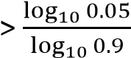
n
n >29
The least value n = 29

Example 6
In Binomial experiment, the probability of a success for n trials is 0.6. If the mean is 7.2, find the
- value of n. (02 marks)
Mean = np 7.2 = 0.6n n = 12
- probability of obtaining 7 success. (03marks)
P(X = x) = ^{n}C_{x}p^{x}q^{(n-x)}
= ¹²C₇(0.6)⁷(0.4)⁵
= 0.227

Example 7
It was observed that 3 seeds in every four seeds planted germinate. If 16 seeds were planted, calculate
- expected number of seeds that will germinate (03marks)
Given p = , q = , n = 16
Let X be the random variable that the seed germinates
XB(16,
E(x) = np = 16 x = 12 seeds
- probability that exactly 14 seeds will germinate (02marks)
P(X = 14) = 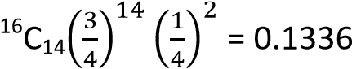

Using Cumulative binomial probability table
The table give values of P(X ≥ x) for values of n and p.
- P(X ≤ X) = 1- (P(X ≥ (X+1)
- P(X = x) + P(X ≥ x) – (PX ≥ x+1)

Example 8
The random variable is distributed B(5, 0.3). Find
(i) P(X ≥ 3) (ii) P(X > 1) (iii) P(X ≤ 4) (iv) P (X < 3) (v) P(X = 2) Solution n = 5, p = 0.3
- P(X ≥ 3) = 0.1631
- P(X > 1) = P(X ≥ 2) = 0.4718
- P(X ≤ 4) = 1 – ( P(X ≥ 5) = 1 – 0.0024 = 0.9976
- P(X < 3) = P(X ≥ 2) = 1 – P(X ≥ 3) = 1 – 0.1631) = 0.8369
- P(X = 2) = P(X ≥ 2) – P(X ≥ 3) 0.4718 – 0.1631 = 0.3087

Example 9
An unbiased coin is tossed 15 times. Find th probability that
- Exactly eight heads will appear upper most
- Between 6 and 10 heads will appear
- Between 6 and 10 heads inclusive will appear Solution n = 15, p = 0.5
- P(X = 8) = P(X ≥ 8) – P(X ≥ 9) = 0.5000 – 0.3036 = 0.1964
- P(6< X < 10) = P(X ≤ X ≤ 9) = P(X ≥ 7) – P(X ≥ 10) = 0.6964 – 0.1509 = 0.5455
- P(X ≤ X ≤ 10) = P(X ≥ 6) – P(X ≥ 11) = 0.8491 – 0.0592 = 0.7899

Example 10
A student attempts 20 objective questions by guest work. Each questions has got four possible alternatives out of which one is correct. Find the probability that he gets
- Exactly 9 correct answers
- At least 12 correct answers
- At most 6 correct answers
- Between 6 and 14 correct answers inclusive (v) Exactly 7 correct answers.
Solution
For correct answers, n = 20, p = 0.25, q = 0.75
- P(X = 9) = P(X ≥ 9) – P(X ≥ 10) = 0.0409 – 0.0139 = 0.027
- P(X ≥ 12) = 0.0009
- P(X ≤ 6) = 1 – P(X ≥ 7) = 1 – 0.2142 = 0.7858
- P(X ≤ X ≤ 14) = P(X ≥ 6) – P(X ≥ 15) = 0.3828 – 0.0000 = 0.3828 For incorrect answers, n = 20, P = 0.75, q = 0.25

Revision exercise 1
- A biased coin is such that a head is three times as likely to occur as a tail. The coin is tossed 5 times. Find the probability that at most two tails occur = 0.8965
- Tom’s chance of passing an examination is . If he sits for four examinations, calculate the probability he passes
- Only two examinations = 0.2963
- More than half of the examinations = 0.5926
- A fair die is rolled 6 times, calculate the probability that
  - A 2 or 4 appears on the first throw 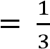
  - Four 5’s will appear in the six throws= 0.0080
- Usain Bolt makes 5 practice ran in the 100m sprint. A run is successful if he runs it in less than 11 seconds. There are 8 chances out of 10 that he is successful. Find the probability that; (i) He records at least no success at all= 0.0003
(ii) Exactly 5 games= 0.3277
- The probability that Alex wins a chess game is . He plays 8 games, what is the probability that he wins
    - At least 7 games= 0.1951
    - Exactly 5 games= 0.2731
- Usain Bolt makes 5 practice ran in the 100m sprint. A run is successful if he runs it in less than 11 seconds. There are 8 chances out of 10 that he is successful. Find the probability that;
    - He records at least no success at all= 0.0003
    - He record at least 2 success= 0.9933
    - If he is successful in 5 practice runs, he makes two additional runs. The probability of success in either of the additional runs is 0.7. Determine the probability that Bolt will make 7 successful runs = 0.1606
- In a test there are 10 objective questions each with a choice of five possible alternatives out of which only one is correct. If a student guesses each of the answers, find the probability that he gets at least two answers correct. = 0.6242
- 30% of the students in the school are day scholars. From a sample of 10 students chosen at random, find the probability that
    - Only 3 are day scholars= 0.267
    - Less than half are day scholars=0.850

- The probability that a shopper buys a cake is 0.25. Find the probability that in a random sample of 9 shoppers
    - Exactly 3 buys a cake=0.2334
    - More than 7 buy a cake= 0.0001
- A bag contains counter books of which 40% are blue and the rest are black. A counter book is taken from the bag, its colour is noted then replaced. This is performed 8 times in all. Calculate the probability that
    - Exactly 3 will be blue= 0.279
    - At least one will be blue= 0.983
    - More than half will be black= 0.594

- At a certain school, the records taken from admission’s office the ratio of male to female s. 5 applicants is 4:6. Basing on this experience, what is the probability that will be more female applicants in a random collection of a dozen applicants? = 0.665
- The random variable X is B(6, 0.42). find
(i) P(X = 6) = 0.00549 (ii) P(X = 4) = 0.157 (iii) P(X ≤ 2) = 0.503
- An unbiased die is thrown seven times. find the probability of throwing at least 5 sixes.= 0.002
- In a family a couple is likely to produce a girl or a boy. Find the probability that in a sample of 5 children there will be more boys than girls = 0.5
- The probability that it will rain on any given day during examination period is 0.3. calculate the probability that in a given week during examination period, it will rain on;
    - Exactly 2 days = 0.318
    - At most two days = 0.647
    - Exactly three days that are consecutive = 0.0324
- A fair coin is tossed 6 times. find the probability of throwing at least four heads = 0.344
- The random variable x is B(4, p) and P(X = 4) = 0.0256. find P(X = 2) = 0.3456
- In agriculture lab, Silvia plants bean seeds and the probability that they germinate successfully is
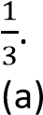 She takes 9 seeds. Find the probability that
        - More than five seeds germinate = 0.0424
        - At least three seeds germinate = = 0.623
(b) Find the number of seeds that she needs to take in order to 99% certain at least one germinate = 12
- In a shooting competition, the probability of hitting the target with a single shot is 0.6, if 7 shots are taken; find the probability that the target is hit more than twice. = 0.9037
- In mass production of shirts, it is found that 5% are defective. Shirts are selected at random of put into packets of 10.
(a) A packet is selected at random. Find the probability that it contains
        - Three defective shirt = 0.0105
        - Less than three defective shirts = 0.9885
(b) Two packets are selected at random. Find the probability that there are no defective shirts in either packet = (¹⁰C₀(0.05)⁰(0.95)¹⁰ x (¹⁰C₀(0.05)⁰(0.95)¹⁰ = 0.358
- A biased coin is such that it is twice as likely to show a head as a tail. If the coin is tossed 5 times.
find the probability that
      - Exactly three heads are obtained = 0.329
      - More than three heads are obtained = = 0.3333
- The probability that a target is hit 0.3. Find the probability the least number of times shots should be fired if the probability that the target is hit is at least once is greater than 0.95. =9
- 1% of the light bulbs in a box are faulty. Find the largest sample size which can be taken if it required that the probability that there is no faulty bulb in the sample is greater than 0.5
(0.99)n > 0.5 n = 68
- In a test there are 10 multiple choice questions. Each question has got four possible alternatives out of which only one is correct. If a student guesses each of the answers, find the probability that he gets
      - More than 7 correct answers = 0.0004
      - More than half correct answers = 0.0197
- X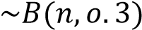. find the value of n such that P(X ≥ 1) = 0.8 :
- The random variable X is B(n, 0.6). find the value of n such that P(X<1) = 0.0256

Solutions to revision exercise 1
1. A biased coin is such that a head is three times as likely to occur as a tail. The coin is tossed 5 times. Find the probability that at most two tails occur Solution n = 5 p + q = 1 x + 3x = 1, x = 0.25
p = 0.25, q = 0.73
P(X ≤ 2) = P(X = 0) + P(X =1) + P(X = 2)
= ⁵C₀ x 0.25⁰ x 0.75⁵ +⁵C₁ x 0.25¹ x 0.75⁴+ ⁵C₂ x 0.25² x 0.75³
=0.2373 + 0.3955 + 0.2637 = 0.8965

2. Tom’s chance of passing an examination is . If he sits for four examinations, calculate the probability he passes
- Only two examinations
n = 4, p = 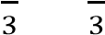, q =
P(X = 2) = 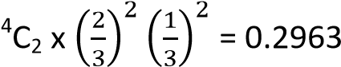
- More than half of the examinations
P(X < 2) = P(X= 3) + P(X =4) = 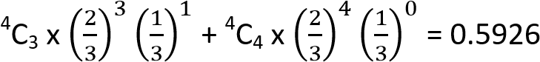
- A fair die is rolled 6 times, calculate the probability that
    - A 2 or 4 appears on the first throw
P( X = 2 or 4) = P(X =2 ) + (X = 4) = 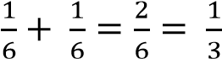
    - Four 5’s will appear in the six throws n = 6, P= 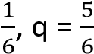
P(X = 4) = 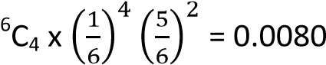
- Usain Bolt makes 5 practice ran in the 100m sprint. A run is successful if he runs it in less than 11 seconds. There are 8 chances out of 10 that he is successful. Find the probability that;
(i) He records at least no success at all n = 5, p = 0.8, q = 0.2
P(X = 0) = ⁵C₀ x 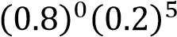 = 0.0003 (ii) Exactly 5 games
P(X = 5) = ⁵C₅ x 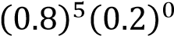 = 0.3277
- The probability that Alex wins a chess game is . He plays 8 games, what is the probability that he wins
(i) At least 7 games n = 8, p = 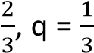
P(X ≤ 7) = P(X = 7) + P(X= 8) = 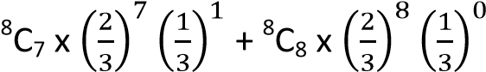
 | =0.1561+ 0.390 = 0.1951
(ii) | Exactly 5 games
P(X =5) = 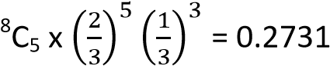
- Usain Bolt makes 5 practice ran in the 100m sprint. A run is successful if he runs it in less than 11 seconds. There are 8 chances out of 10 that he is successful. Find the probability that;
    - He records at least no success at all n = 5, p = 0.8, q = 0.2
P(X = 0) = ⁵C₀ x 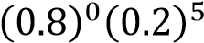 = 0.0003
    - He record at least 2 success
P(X ≥ 2) = 1 –P(X <2) = 1- [P(X=0) + P(X = 1)
= 1 – [⁵C₀ x 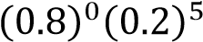+ ⁵C₁ x 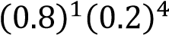) = 1- (0.0003 + 0.0064) = 0.9933
    - If he is successful in 5 practice runs, he makes two additional runs. The probability of success in either of the additional runs is 0.7. Determine the probability that Bolt will make 7 successful runs
Probability = ⁵C₅x 0.8⁵ x 0.2⁰ and ²C² x 0.7²(0.3)⁰
= 0.32768 x 0.49= 0.1606
- In a test there are 10 objective questions each with a choice of five possible alternatives out of which only one is correct. If a student guesses each of the answers, find the probability that he gets at least two answers correct. Solution
n = 10, p = 0.2, q = 0.8
P(X ≥ 2) = 1- P(X<2)
= 1 – [P(X = 0) + P(X = 1)
= 1 – [ ¹⁰C₀ x 0.2⁰ x 0.8¹⁰ x ¹⁰C₁ x 0.2¹ x 0.8⁹)
= 1- (0.1074 + 0.2684) = (1 – 0. 3758) = 0.6242
- 30% of the students in the school are day scholars. From a sample of 10 students chosen at random, find the probability that
(i) Only 3 are day scholars
n = 10, p = 0.3, q = 0.7
P(X = 3) = ¹⁰C₃(0.3)³(0.7)⁷ = 0.267
(ii) Less than half are day scholars
P(X < 5) = P(X = 0) + P(X = 1) + P(X = 2) + P(X = 3) + P(X = 4)
=¹⁰C₀(0.3)⁰(0.7)¹⁰ + ¹⁰C₁(0.3)¹(0.7)⁹ + ¹⁰C₂(0.3)²(0.7)⁸ + ¹⁰C₃(0.3)³(0.7)⁷
10 4 6
+ C₄(0.3) (0.7)
=0.850
- The probability that a shopper buys a cake is 0.25. Find the probability that in a random sample of 9 shoppers
    - Exactly 3 buys a cake n = 9, p = 0.25, q = 0.75
P(X = 3) = ⁹C₃(0.25)³(0.75)⁶ =0.2334
    - More than 7 buy a cake
P(X > 7) = P(X = 8) + P(X = 9)
= ⁹C₈(0.25)⁸(0.75)¹ + ⁹C₉(0.25)⁹(0.75)⁰ = 0.0001
- A bag contains counter books of which 40% are blue and the rest are black. A counter book is taken from the bag, its colour is noted then replaced. This is performed 8 times in all. Calculate the probability that
(i) Exactly 3 will be blue
n = 8, p = 0.4, q = 0.6
P(X = 3) = ⁸C₃(0.4)³(0.6)⁵ = 0.279
(ii) At least one will be blue
P(X ≥ 1) = 1 – P(X<1) = 1- P(X=0) = 1 – ⁸C₀(0.4)⁰ (0.6)⁸ = 0.983 (iii) More than half will be black

P(X≤3) = P(X = 0) + P(X= 1) + P(X = 2) + P(X = 3)
=⁸C₀(0.4)⁰ (0.6)⁸ + ⁸C₁(0.4)¹ (0.6)⁷ + ⁸C₂(0.4)² (0.6)⁶ + ⁸C₃(0.4)³ (0.6)⁵ = 0.594
- At a certain school, the records taken from admission’s office the ratio of male to female s. 5 applicants is 4:6. Basing on this experience, what is the probability that will be more female applicants in a random collection of a dozen applicants? Solution
n = 12, p = 0.4, q = 0.6
P(X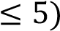 = P(X = 0) + P(X =1) + P(X =2) + P(X= 3) + P(X = 4) + P(X = 5)
= ¹²C₀(0.4)⁰ (0.6)¹² + ¹²C₁(0.4)¹ (0.6)¹¹ + ¹²C₂(0.4)² (0.6)¹⁰ + ¹²C₃(0.4)³ (0.6)⁹ +
¹²C₄(0.4)⁴ (0.6)⁸ + ¹²C₅(0.4)⁵ (0.6)⁷
= 0.6652
- The random variable X is B(6, 0.42). find
(i) P(X = 6) n = 6, p = 0.42, q= 1- 0.42= 0.58
P(X = 6) = ⁶C₆(0.42)⁶(0.58)⁰ = 0.00549 (ii) P(X = 4) 6 4 2
C₄(0.42) (0.58) = 0.157
(iii) P(X ≤ 2)
P(X ≤ 2) = P(X = 0) + P(X = 1) + P(X= 2)
=⁶C₀(0.42)⁰(0.58)⁶ + ⁶C₁(0.42)¹(0.58)⁶+ ⁶C₂(0.42)²(0.58)⁴= 0.503
- An unbiased die is thrown seven times. find the probability of throwing at least 5 sixesn = 7, p = 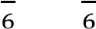, q =
P(X ≤ 5) = P(X = 5) + P(X = 6) + P(X = 7)
- In a family a couple is likely to produce a girl or a boy. Find the probability that in a sample of 5 children there will be more boys than girls
n = 5, p = 0.5, q = 0.5
P(X ≥ 3) = P(X = 3) + P(X = 4) + P(X= 5)
= ⁵C₃(0.5)³(0.5)² +⁵C₄(0.5)⁴(0.5)¹ + ⁵C₅(0.5)⁵(0.5)⁰ = 0.5
- The probability that it will rain on any given day during examination period is 0.3. calculate the probability that in a given week during examination period, it will rain on;
      - Exactly 2 days n = 7, p = 0.3, q = 0.7
P(X = 2) = ⁷C₂(0.3)²(0.7)⁵= 0.318
      - At most two days = 0.671
P(X ≤ 2) = P(X = 0) + P(X = 1) + P(X = 2)
=⁷C₀(0.3)⁰(0.7)⁷ + ⁷C₁(0.3)¹(0.7)⁶ + ⁷C₂(0.3)²(0.7)⁵ = 0.647
- A fair coin is tossed 6 times. find the probability of throwing at least four heads n = 6, p = 0.5, q = 0.5
P(X ≤ 4) = P(X = 4) + P(X =5) + P(X =6)
= ⁶C₄(0.5)⁴(0.5)² + ⁶C₅(0.5)⁵(0.5)¹ + ⁶C₆(0.5)⁶(0.5)⁰= 0.344

- The random variable x is B(4, p) and P(X = 4) = 0.0256. find P(X = 2) n = 4, p = p, q = (1-p) P(X = 4) = ⁴C₄(p)⁴(q)⁰ = 0.0256
(p)⁴= 0.0256; p = 0.4
P(X = 2) =⁴C₂(0.4)²(0.6)²= 0.3456
- In agriculture lab, Silvia plants bean seeds and the probability that they germinate successfully is
.
(a) She takes 9 seeds. Find the probability that
      - More than five seeds germinate
P(X<5) = P(X =6) + P(X = 7) + P(X = 8) + P(X = 9)
      - At least three seeds germinate
P(X ≥ ) = 1 –[P(X=0) + P(X = 1) + P(X = 2)]
(b) Find the number of seeds that she needs to take in order to 99% certain at least one germinate
P(X≤ 1) = 1 – P(X = 0) = 1 -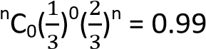
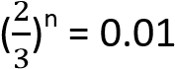
n = 11.36
therefore the number = 12
- In a shooting competition, the probability of hitting the target with a single shot is 0.6, if 7 shots are taken; find the probability that the target is hit more than twice.
n = 7, p = 0.6, q = 0.4
P(X > 2) = 1 – P(X ≤2) = 1 – [P(X = 0) + P(X = 1) + P(X =2)]
= 1- [⁷C₀(0.6)⁰(0.4)⁷ + ⁷C₁(0.6)¹(0.4)⁶ +⁷C₂(0.6)²(0.4)⁵] = 0.9037
- In mass production of shirts, it is found that 5% are defective. Shirts are selected at random of put into packets of 10.
(a) A packet is selected at random. Find the probability that it contains
      - Three defective shirt
P(X= 3) = ¹⁰C₃(0.05)³(0.95)⁷= 0.0105
      - Less than three defective shirts
P(X < 3) = P(X = 0) + P(X = 1) + P(X=2)
= ¹⁰C₀(0.05)⁰(0.95)¹⁰ x ¹⁰C₁(0.05)¹(0.95)⁹ + ¹⁰C₂(0.05)²(0.95)⁸= 0.9885
(b) Two packets are selected at random. Find the probability that there are no defective shirts in either packet = (¹⁰C₀(0.05)⁰(0.95)¹⁰ x (¹⁰C₀(0.05)⁰(0.95)¹⁰ = 0.358
- A biased coin is such that it is twice as likely to show a head as a tail. If the coin is tossed 5 times.
find the probability that
      - Exactly three heads are obtained n = 5, p = , q =
P(X = 3) = 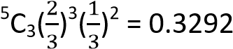
      - More than three heads are obtained = 0.3333
P(X > 3) = P(X = 4) + P(X = 5)
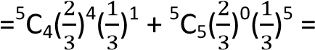
- The probability that a target is hit 0.3. Find the probability the least number of times shots should be fired if the probability that the target is hit is at least once is greater than 0.95. =9 n = ? p = 0.3, q = 0.7
P(X ≥ 1) = 1 – P(X = 0) = 1 - ^{n}C₀(0.3)⁰(0.7)^{n} > 0.95
(0.7)^{n} > 0.05

n = 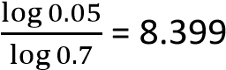
therefore n =9
- 1% of the light bulbs in a box are faulty. Find the largest sample size which can be taken if it required that the probability that there is no faulty bulb in the sample is greater than 0.5
(0.99)n > 0.5 n = 68
- In a test there are 10 multiple choice questions. Each question has got four possible alternatives out of which only one is correct. If a student guesses each of the answers, find the probability that he gets
    - More than 7 correct answers = 0.0004
    - More than half correct answers = 0.0197
- X. find the value of n such that P(X ≥ 1) = 0.8 : 0.7^{n} = 0.2. = 5
- The random variable X is B(n, 0.6). find the value of n such that P(X<1) = 0.0256
0.4^{n} = 0.0256, n = 4

Expectation, variance and standard deviation
If XB(n, p)
E(X) = np
Var(X) = npq where q = 1- p
s.d =
√

Example 9
The random variable x is B(4, 0.8). the mean, variance and standard deviation
Mean = np = 4 x 0.8 = 3.2
Variance = npq = 4 x0.8 x 0.2 = 0.64
s.d = 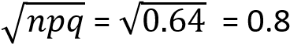

Example 11
The probability that, it will be a sunny day is 0.4. Find the expected number if sunny days in a week and also find the standard deviation
Solution
E(X) = np = 7 x 0.4 = 2.8
s.d =

Example 12
X is B(n, p) with mean 5 and standard deviation2. Find the value of n and p. E(X) = np np = 5 ………………….. (i)
s.d =
√

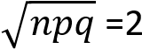
npq = 4 …………………(ii)
Eqn. (ii) eqn. (i)
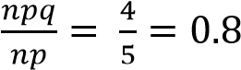
q = 0.8 p = 0.2
n = 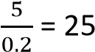
Mode of the binomial distribution
The mode is the value of X that is most likely to occur. The value of X with the highest probability and its close to the mean gives the mode.

Example 13
The probability that a student is awarded a distinction in mathematics examination is 0.15. In a randomly selected group of 15 students, what is the most likely number of students awarded a distinction
Solution
E(X) = np = 15 x 0.15 = 2.25
P(X = 2) = ¹⁵C₂(0.15)²(0.85)¹³ = 0.286
P(X = 3) = ¹⁵C₃(0.15)³(0.85)¹² = 0.216
The most likely number of students awarded a distinction = 2

Example 14
In a school 80% of the students find difficulties in Physics. If a sample of 12 students is chosen
- What is the most likely number of students who find it difficult in physics.
E(X) = np = 0.8 x 12 = 9.6
P(X = 9) = ¹²C₉(0.8)⁹(0.2) ³ = 0.236
P(X = 10) = ¹²C₁₀(0.8)¹⁰(0.2) ² =0.294
The most likely number is 10
- Find the probability that fewer than half find difficulty in Physics. P(X<6) = 0.0004

Revision exercise 2
- 10% of drugs at a certain Pharmacy are expired. A sample of 25 drugs is taken. Find the expected number and standard deviation of expired drugs (25,1.5)
- The probability that a student scores above 60% in mathematics test is0.5. In a random sample of
15 students, what is the most likely number of students who score above 60%. (7 and 8)
- The probability that an apple picked at random from a sack is bad is 0.15.
  - Find the standard deviation of the number of bad apples in a sample of 15 apples.=1.38
  - What is the most likely number of bad apples in a sample of 30 apples = 4
- The random variable X is B(n, 0.3) and E(X) = 2.4. Find n and standard deviation (8, 1.30)
- In a group of people, the expected number who wear glasses is 2 and the variance is 1.6, find the probability that;
  - A person chosen at random from the group wear glasses = 0.2
  - 6 people in the group wear glasses. =0.00551
- New vision publishes a governance article in its newspaper each day of the week Sunday. A man is able to read 8 out of ten articles
  - Find the expected value and the standard deviation of the number of read articles in a given week= 4.8
  - What is the probability that he will read at least 5 articles in a given week? = 0.98
- A die is biased and probability, p of throwing a six is known to be less than . An experiment consists of recording the number of sixes n 25 throws of the die. The standard deviation of the number of sixes I 1.5. calculate the
  - value of p. = 0.1
  - the probability that exactly three sixes are recorded during a particular experiment = 0.23
- The random variable X is B(10, p) where p < 0.5. The variance of X is 1.875. find
  - Value of p. = 0.25
  - E(X) = 2.5
  - P(X = 2) = 0.282
- In a bag there are 6 red pens, 8 blue pens and 6 black pens. an experiment consists of taking a pen at random from the bag, noting its colour and then replacing it in the bag. This procedure is repeated 10 times in all. find
  - Expected number of red pens drawn=3
  - Most likely number of black pens drawn = 3
  - Probability that not more than four blue pens are drawn = 0.633
- The random variable X is distributed binomially with mean 2 and variance 1.6, Find
  - the probability that x is less than 6 = 0.994
  - the most likely value of X = 2
- Each day a bakery delivers the same number of loaves to a certain shop which sells on average98%of them. Assuming that the number of loaves sold per day has a binomial distribution with standard deviation 7. Find the expected number of loaves the shop would expect to sell per day = 2500
- On average 20% of the bolts produced by a machine are faulty. Samples of 10 bolts are to be selected at random each day. Each bolt will be selected and replaced in the set of bolts which have been produced on that day.
  - Find the probability that in any one sample, two bolts or less will be faulty = 0.68
  - Calculate the expected value and variance of the number of bolts in a sample which will not be faulty. = 8, 1.6
- An experiment consists of taking 12 shots at a target and counting the number of hits. The expected number of hit was found to be 3. Calculate
  - The probability of hitting the target with a single shot. = 0.25
  - Standard deviation of the number of hits in an experiment = 1.5
- In a certain family, the probability that they will have a baby boy is 0.6. If there are 5 children in a family determine
  - Expected number of girls = 2
  - The probability that there are at least three girls = 0.317
  - The probability they are all boys. = 0.0778
- The probability of winning a game is 0.8. Ten games are played. What is the;
  - Mean number of success and variance. = 8, 1.6
  - The probability of at least 8 success in the ten = 0.6778
- In a test there are 10 multiple choices questions. Each question has four possible alternatives out of which one is correct. If a student guesses each of the answers, find the
  - The probability that at least fur answers are correct = 0.2241
  - Most likely number of correct answers = 2
- A biased coin is such that a head is twice as likely to occur as a tail. the coin is tossed 15 times. Find the
  - The expected number of heads = 10
  - Probability that at most two tails occur = 0.0793

Solutions to revision exercise 2
- In a certain family, the probability that they will have a baby boy is 0.6. If there are 5 children in a family determine
  - Expected number of girls n = 5, p = 0.4, q = 0.6 E(X) = np = 5 x 0.4 = 2
  - The probability that there are at least three girls
P(X≤3) = P(X= 3) + P(X = 4) + P(X = 5)
= ⁵C₃(0.4)³(0.6)² + ⁵C₄(0.4)⁴(0.6)¹ +⁵C₅(0.4)⁵(0.6)⁰ = 0.317 (c) The probability they are all boys. P(X = 0) = ⁵C₀(0.4)⁰(0.6)⁵= 0.0778
- The probability of winning a game is 0.8. Ten games are played. What is the; (a) Mean number of success and variance. Mean = np = 10 x 0.8 = 8
Variance = npq = 10 x 0.8 x 0.2 =1.6
(b) The probability of at least 8 success in the ten
P(X ≤ 8) = P(X = 8) + P(X = 9) + P(X = 10)
= ¹⁰C₈(0.8)⁸(0.2)² + ¹⁰C₉(0.8)⁹(0.2)¹ + ¹⁰C₁₀(0.8)¹⁰(0.2)⁰ = 0.6778
- In a test there are 10 multiple choices questions. Each question has four possible alternatives out of which one is correct. If a student guesses each of the answers, find the
  - The probability that at least four answers are correct n = 10, p = 0.25, q = 0.75
P(X ≥ 4) = 1 –P(X ≤ 3) = 1 – [P(X= 0) + P(X= 1) + P(X = 2) + P(X = 3)
= 1 – [¹⁰C₀(0.25)⁰(0.75)¹⁰+¹⁰C₁(0.25)¹(0.75)⁹+¹⁰C₂(0.25)²(0.75)⁸+¹⁰C₃(0.25)³(0.75)⁷]
= 0.2241
  - Most likely number of correct answers
E(X) = np = 0.25 x 10 = 2.5
P(X = 2) =¹⁰C₂(0.25)²(0.75)⁸ = 0.2816
P(X = 3) =¹⁰C₃(0.25)³(0.75)⁷ = 0.2503 the most likely number of correct answers = 2
- A biased coin is such that a head is twice as likely to occur as a tail. The coin is tossed 15 times. Find the
  - The expected number of heads n =15, p = 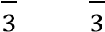, q =
E(X) = np = 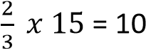
  - Probability that at most two tails occur n = 15, p = , q =
P(X≤ 2) = P(X = 0) + P(X = 1) + P(X =2)

Normal distribution
A continuous random variable X follows a normal distribution with mean, μ and variance, σ² if
XN(μ, σ²) root
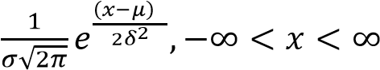

Its p.d.f is given by fx =

A sketch of f(x)
gives a normal curve

f(x)

-

𝜇

+

𝜎
√

𝜋
𝑒
(
𝑥

𝜇
)

𝛿

Properties of the curve

-
It is bell shaped

-
It is symmetrical about
μ

-
It extends from

𝑥

The maximum value of f(x) =

𝜎
√

𝜋
𝑒
(
𝑥

𝜇
)

𝛿

-
The total area under the curve = 1

How to read the cumulative normal distribution table
- Between 0 and any z value
  - P(0 ≤ Z ≤ Z₁) = φ(Z₁) = region P (b) P(-Z₁≤ Z ≤ 0)= P(0 ≤ Z ≤ Z₁) = φ(Z₁) = region P By symmetrical

-
Z
1

Z
P

Z
1

Z
P

- Less than any positive z value
  - P(Z < Z₁) = 0.5 + P(0 ≤ Z ≤ Z₁) = φ(Z₁) = region P
  - P(Z > -Z₁) = P(Z < Z₁) = 0.5 + P(0 ≤ Z ≤ Z₁) = 0.5 + φ(Z₁) = region P By symmetrical

-
Z
1

Z

Z
1

Z

P

- Greater than any positive z value
P(Z > Z₁) = 0.5 - P(0 ≤ Z ≤ Z₁) = 0.5 - φ(Z₁) = region P
P(Z < -Z₁) = P(Z > Z₁) = 0.5 - P(0 ≤ Z ≤ Z₁) = 0.5 - φ(Z₁) = region P

By symmetrical

t

-
Z
1

Z

Z
1

Z

P

Example 15
Find
- P(Z< 2)
By symmetry

2

P(Z< 2) = 0.5 + φ(2)
= 0.5 + 0.4772
= 0.9772

- P(Z > 0.85)

0.85

P(Z > 0.85) = 0.5 - φ(0.85) = 0.5- 0.3023
= 0.1977

- P(X< 0.345)

0.345

P(X< 0.345) = 0.5 + φ(0.345)
= 0.5 + 0.1331 + 0.0019
= 0.6350

Example 16
Find
- P(Z < -0.25)
By symmetry
=

-
0.25

Z

0.25

P

P(Z < -0.25) = P(Z > 0.25) = 0.5 - φ(0.25)
= 0.5 – 0.0987
= 0.4013

- P(Z > -1.377)
By symmetry

=

-

1.377

1.377

P(Z > -1.377) = P(Z < 1.377)
= 0.5 + φ(1.377)
= 0.5 + 0.4147 + 0.0011
= 0.9158
- P(Z < -1.377)
By symmetry
=

-
1.377

0

Z

1.377
Z

P(Z < -1.377) = P(Z > 1.377
= 0.5 - φ(1.377)
= 0.5 – (0.4147 + 0.0011)
= 0.0842
Standardizing a random variable X
If a random variable X follows a normal distribution with mean, μ and variance, σ², then X N(μ, σ²) and can be standardized using the equation below and read from a cumulative normal table
Z = 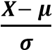
Example 3
Given that the random variable X is X N(300, 25). Find
  - P(X > 305)
P(X> 305) = 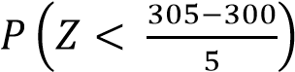
= P(X > 1)

1
Z

= 0.5 – φ(1)
= 0.5 – 0.3413 = 0.1587

  - P(X < 291)
P(X < 291) 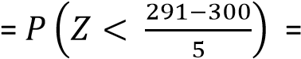 P(Z < -1.8)

1.8
Z
By symmetry

=

-1.8 0 Z

P(Z < -1.8) = P(Z >1.8)
= 0.5 - φ(1.8)
= 0.5 – 0.4641
= 0.0359

  - P(X < 312)
P(X < 312) = 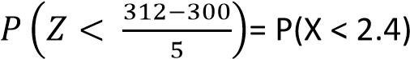

2.4

= P(X < 2.4) = 0.5 + φ(2.4)
= 0.5 – 0.4918 = 0.9918
  - P(X > 286)
P(X > 286) 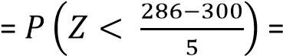 P(Z < -2.8

-
2.8

= P(Z < 2.8)
= 0.5 + φ(2.8)
= 0.5 + 0.4974= 0.9974

Applications

Example 17
A bakery produces loaves of bread whose weight is normally distributed with mean 1,000g and standard deviation 40g.
- Find the probability that a randomly selected loaf has a weight of utmost 1,020g.
μ = 1000, σ = 40
Let x be the weight of bread
P(x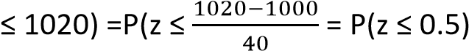

0.5
Z

P(z ≤ 0.5)= 0.5 + P(0≤ x≤ 0.5)
= 0.5+0.1915
= 0.6915
- Assuming that the bakery makes 10,500 loaves, find the approximate number of loaves with weight greater than 950g.
P(x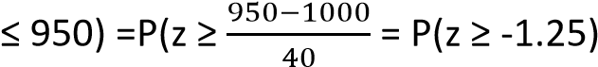

-
1.25

P(z ≥ -1.25)= P(-1.25≤ z≤ 0) + 0.5
= (0 ≤ z ≤ 1.25) + 0.5
= 0.5 +0.3944
= 0.8944
Number of loaves = 0.8944 x 10,500 = 9391

Example 18
A factory sells animals food in bags. The weights of the bags are normally distributed with mean weight 50kg and standard deviation 2.8kg.
- Find the probability that the weight of any bag selected at random;
Let X = random variable for weight of bags
Given μ = 50 and σ = 2.8kg
  - is more than 53kg (04marks)
P(X> 52) = P(Z> 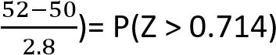

0
0.714

P(Z > 0.714) = 0.5 – P(0 < Z < 0.714)
= 0.5 – 0.2623
= 0.2377
  - lies between 46 and 55kg (05marks)
P(46 < X < 55) = P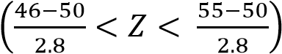
= P(-1.429< Z < 1.786)

-
1.429
0 1.789

P(-1.429< Z < 1.786) = P(0 <Z< 1.429) + P(0 < Z < 1.789)
= 0.4235 + 0.4630
= 0.8865
- Determine the percentage of bags whose weights are less than 54kg. (06marks)
P(X< 54) = P(Z < 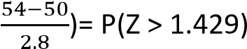

-
1.429

0

1.429

P(Z > 1.429) = 0.5 + P(0 < Z < 1.429)
= 0.5 + 0.4235
= 0.9235

Example 19
The marks scored by candidates in an examination are normally distributed with a mean score of μ and standard deviation of δ. Given that 37.5% of the candidates scored below 40 and that 12.5% scored above 60, find the;
- values of μ and δ. (09marks)
Let X be marks scored
P( X < 40) = 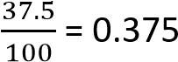
P(x< 40) = P(Z < Z₀) = 0.375


-
Z
0

Z
0
0

0.375

0.375

By symmetry, P(Z < Z₀) = P(Z > Z₀)
But Z = 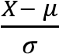
-0.319 =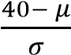
μ – 0.319σ = 40 …………………….(i)
P(X> 60) = P(Z > Z₁) = 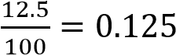



0
Z
1

0.125

P(0 < Z < Z₁) = 0.875
Z₁ = 1.15
⇨ 1.15 =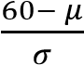
μ – 0.319σ = 60 …………………….(ii)
from equation (i) and (ii) σ = 13.6 and μ= 44.4
- probability that a candidate score between 46 and 55. (06 marks)
P(46< X < 55 =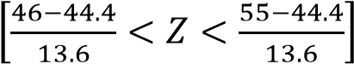
= P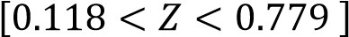

0
0.118 0.779
= P(0 < Z < 0.779) – P(0<Z<0.118)
= 0.2822 -0.0470
= 0.2352

Example 20
The time taken for a bus to make a journey is normally distributed with mean 3 ½ hours and standard deviation ¾ hours.
- Determine the probability that the bus makes a journey:
  - in less than 2 hours (05marks)
Solution
P(X < 2) = P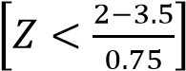
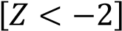

P
=

By symmetry, P
[

]

=

P
[

]

P

0.5
=
–

2)
Z<
(0<

-
0
2

0
2

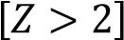
= 0.5 – 0.4772
= 0.0228
Hence the probability = 0.0228
  - between 3¼ and 3¾ hours (07 marks)
Solution
P(3.25<X 3.75) = P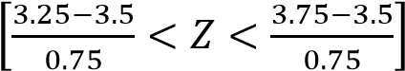
= P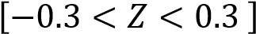

-
0.3
0 0.3

P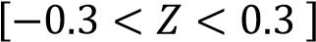 = 2P(0 < Z< 0.3)
= 2 x 0.1179
= 0.2358
- If the bus made two hundred journeys, how many of these journeys did it take less than 2 hours? (03 marks)
Number of journeys that take less than 2 hours = 0.0228 x 200 = 4

Example 21
A bakery produces loaves of bread whose weight is normally distributed with mean 1,000g and standard deviation 40g.
- Find the probability that a randomly selected loaf has a weight of utmost 1,020g.
μ = 1000, σ = 40
Let x be the weight of bread
P(x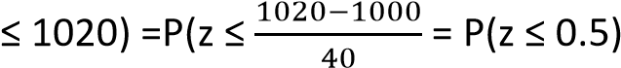

0.5
Z

P(z ≤ 0.5)= 0.5 + P(0≤ x≤ 0.5)
= 0.5+0.1915
= 0.6915
- Assuming that the bakery makes 10,500 loaves, find the approximate number of loaves with weight greater than 950g.
P(x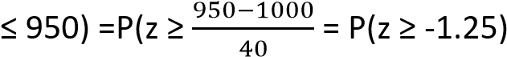

-
1.25

P(z ≥ -1.25)= P(-1.25≤ z≤ 0) + 0.5
= (0 ≤ z ≤ 1.25) + 0.5
= 0.5 +0.3944
= 0.8944
Number of loaves = 0.8944 x 10,500 = 9391 Example 22
Given that the random variable X is X N(10, 4). Find
Find (i) P(X < 7) (ii) P(X > 12) (iii) P(7 < X < 12) (iv) P(9 < X < 11)
Solution
- P(X < 7) = 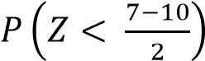= P(Z < - 0.15) = P(Z > 1.5)
= 0.5 – φ(1.5) = 0.5 – 0.4332 0.0668
- P(X > 12) =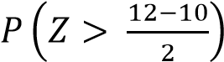= P(Z > 1) = 0.5 – φ(1) = 0.5 – 0.3413 = 0.1587
- P(7 < X < 12) = 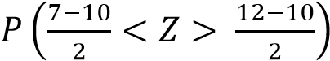
= P(-1.5 < Z < 1) = φ(1.5) + φ(1) = 0.4332 + 0.3413 = 0.7745
- P(9 < X < 11) = 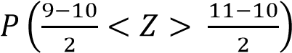
= P(-0.5 < Z < 0.5) = φ(0.5) + φ(0.5) = 2 x 0.1915 = 0.3830

Example 23
Given that the random variable X is X N(50, 8). Find
(i) P(48 < X < 54) (ii) P(52 < X < 55) (iii) P(46 < X < 49) (iv) P(|X-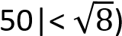
Solution
- P(48 < X < 54) = 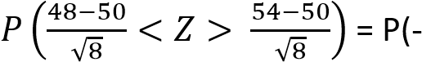0.707 < Z < 1.414)
= φ(1.414) + φ(0.707) = 0.4213 + 0.2601 = 0.6814
- P(52 < X < 55) = 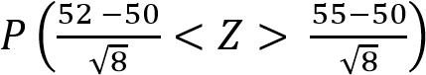= P(0.707 < Z < 1.768)
= φ(1.768) - φ(0.707) = 0.4615 -0.2601 = 0.2014
- P(46 < X < 49) =
=φ(1.414) – φ(0.354) = 0.4213 – 0.1383 -0.283
1 < X < 1) = 2 x φ(1) = 2 x 0.3413 = 0.6826

Example 24
A random variable X is normally distributed with mean 65 and variance 100, find the probability that X assumes a value between 50 and 90.
P(50 < X < 90) = 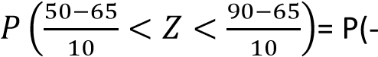1.5 < Z < 2.5) = φ(1.5) + φ(2.5) = 0.4332 + 0.4938 = 0.927

Example 25
Lengths of metal strips produced by a machine are normally distributed with mean length of 150cm and standard deviation of 10cm. find the probability that the length of a randomly selected strip is (i)shorter than 165 (ii) within 5cm of the mean
Solution
P(X < 165) = 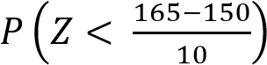=P(Z< 1.5) = 0.5 + φ(1.5) = 0.5 + 0.4332 = 0.9332
P(150 – 5 < X < 150 + 5) = 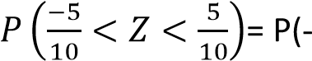0.5 < Z < 0.5) = 2 x φ(0.5) = 2 x 0.1915 = 0.383

Example 26
In end of year exams, the marks are normally distributed with a mean mark of 50 and standard deviation 5. If a mark 45 is required to pass the exam, what percentage of the students failed the exam.
P(X < 45) = 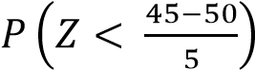= P(Z < -1) = P(Z > 1) = 0.5 – φ(1) = 0.5 – 0.3413 = 0.1587

Example 9
A bakery supplies bread to a shop every day. The time to deliver bread to the shop is normally distributed with mean 12 minutes and standard deviation of 2 minutes. Estimate the number of days the year when he takes
(i) longer than 17 minutes (ii) less than 10 minutes (iii) between 9 and 13 minutes Solution
- P(X > 17) = 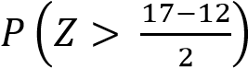= P(Z > 2.5) = 0.5 – φ(2.5) = 0.5 – 0.4938 = 0.0062
The number of days = 0.0062 x 365 = 2 days
- P(X < 10) =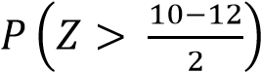= P(Z < -1) = P(Z> 1) = 0.5 – φ(1) + 0.5 – 0.3413 0.1587
The number of days = 0.1587 x 365 = 58 days.
- P(9 < X <13) = 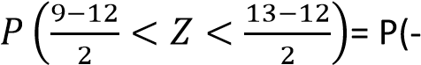1.5 < Z < 0.5) = φ(1.5) + φ(0.5) 0.4332 + 0.1915 = 0.6247
Number of days = 0.6247 x 365 = 228 days.

Example 28
- In a certain athletics competition, points are awarded according to level of performance. The average grade was 82 points with standard deviation of 5 points. All competitors whose grades ranged between 88 to 94 points received certificates. If the grades are normally distributed and 8 competitors received certificates. How many participants took part in the competition?
P(88 < X < 94) = 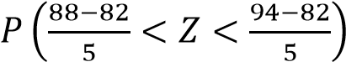= P(1.2 < Z < 2.4) =
; n = 74.84
hence 75 participants took part.
- If certificates were to be awarded to only those having between 90 and 94 points. What proportion of the participants would acquire certificates.
P(90 < X < 94 = 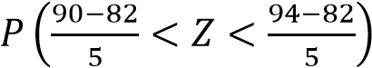=P(1.6 < Z < 2.4 = φ(2.4) – φ(1.6)
= 0.4918 – 0.4452 = 0.0466
= 0.0466 x 100% = 4.66%

Revision exercise 3
- The amount of meat sold by a butcher is normally distributed with mean 43kg and standard deviation 4kg. Determine the probability that the amount of meat sold is between 40kg and 50kg. (0.7333)
- Given that a random variable X is XN(2, 2.89). Find P(X<0)(0.1198)
- In a school of 800 students their average weight is 54.5kg and standard deviation 6.8kg. given that the weight of students are normally distributed, find
  - Probability that the weight of any student randomly selected is 52.8 kg or less = 0.4014 (ii) Number of students who weigh over 75kg = 1
(iii) Weight of the middle 56% of the students (49.251< X < 59.750)
- A sugar factory sells sugar in bags of mean weight 50kg and standard deviation 2.5kg. given that the weight of the bags is normally distributed, find the
  - Probability that the weight of any bag of sugar randomly selected lies between 51.5kg and 53kg = 0.1592
  - Percentage of bags whose weight exceeds 54kg = 5.48%
  - Number of bags that will be rejected out of 1000 bags purchased for weighing below 45.0kg = 23
- A certain maize firm sells maize in bags of mean weight 40kg and standard deviation 2kg, given that the weight of the bags are normally distributed, find
  - Probability that the weight of any bag of maize randomly selected lies between 41.0 and
42.5kg = 0.2029
  - Percentage of bags whose weight exceeds 43kg = 6.68%
  - Number of bags that will be rejected out of 500 bags purchased for weighing below 38.5kg = 113
- Given that the random variable X is XN(300, 25) Find
  - P(X>308) = 0.0548 (ii) P(X> 311.5) = 0.0107 (iii) P(X < 294) = 0.8849
(iv) P(X < 290.5) = 0.9713 (v) P(X > 302) = 0.6554 (vi) P(X > 312) = 0.9918
- If XN(50, 20). Find
  - P(X > 60.3) = 0.0106 (ii) P(X < 47.3) = 0.273 (iii) P(X > 48.9) = 0.5972
(iv) P(X > 53.5) = 0.2831 (v) P(X < 59.8) = 0.9857 (vi) P(X < 62.3) = 0.9970
- If XN(-8, 12). Find
  - P(X < -9.8) = 0.1587 (ii) P(X > 0) = 0.8413 (iii) P(X < -3.4) =0.9079
(iv) P(X > -5.7) =0.2533 (v) P(X < 10.8) = 0.2097 (vi) P(X > -1.6) = 0.0323
- If XN(α, α²) . Find
  - P(X < 0) = 0.1587 (ii) P(X > 0) = 0.8413 (iii) P(X < 0.5α) = 0.6915 P(X > 0.5α) = 0.3085
- If XN(100, 80) . Find
  - P(85 < X < 112) = 0.8634 (ii) P(105 < X < 115) = 0.2413
(iii) P(85 < X < 92) = 0.1388 (iv) P(|X|<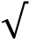 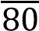 = 0.6826
- If XN(84, 12) . Find
  - P(80 < X < 89)= 0.8014 (ii) P(X <79 or X > 92) = 0.085 (iii) P(76 < X < 82) = 0.2714
(iv) P(|X- 84|> 2.9) = 0.4028 (v) P(87 < X < 93) = 0.1886
- The masses of packages from a particular machine are normally distributed with a mean of 200g and standard deviation of 2g, find the probability that a randomly selected package from the machine weighs
  - less than 197g = 0.0668
  - more than 200.5g = 0.4013
  - between 198.5g and 199.5g = 0.1747
- The heights of boys at a certain school follow a normal distribution with mean = 150.3cm and variance 25cm, find the probability that a boy picked at random from the group has a height;
  - less than 153cm = 0.7054
  - more than 158cm = 0.018
  - between 150 cm and 158 cm= 0.4621
  - more than 10cm difference from the mean height = 0.0046
- The masses of a certain type of cabbages are normally distributed with mean of 1000g and standard deviation of 0.15kg. In a batch of 800 cabbages, estimate how many have a mass between 750g and 1290g = 740
- Cartons of milk from quality super market are advertised as containing 1 litre, but in fact the volume of the content is normally distributed with a mean of 1012ml and standard deviation of 15ml.
  - Find the probability that a randomly chosen carton contains more than 1010ml =0.6554
  - In a batch of 1000 cartons, estimate the number of cartons containing less than the advertised volume of milk =8
- A random variable X is such that XN(-5, 9). Find the probability that;
  - A randomly chosen item from the population will have positive value = 0.0478
  - Out of 10 items chosen randomly, exactly 4 will have a positive value = 0.00082
- The life of a laptop is normally distributed with a mean of 2000 hours and standard deviation of 120 hours. Estimate the probability that the life of such a laptop will be
  - greater than 2150 hours = 0.1056
  - greater than 1910hours = 0.7734
  - within a range 1850 hours to 2090 hours = 0.6678
- Height of female students at particular college are normally distributed with mean 169cm and standard deviation 9cm.
If X stands for the height of students in cm. find
  - P(X < X₀) = 0.8 [176.578]
  - P(X>v1) = 0.6 [166.723]
- The marks of 500 candidates in an examination are normally distributed with mean 45 marks and standard deviation 20 marks.
  - Given that the pass mark is 41, estimate the number of students who passed the examination. [290]
  - If 15% of the candidates obtained a distinction by scoring mark x or more, estimate the value of x. [77.9]
- The mass of soap powder in certain packets is normally distributed with mean 842 grams and variance 225 grams².
Find the probability that a random sample of 120 packets has mass
  - Between 844 grams and 846 [0.0702]
  - Less than 843 grams [0.7673]

Solutions to revision questions 1
- The amount of meat sold by a butcher is normally distributed with mean 43kg and standard deviation 4kg. Determine the probability that the amount of meat sold is between 40kg and 50kg.
X N(43,4)
P(40<x<50) = 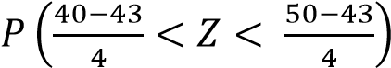
= P(- 0.75 < Z < 1.75)
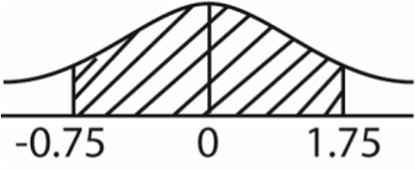
P(40<x<50) = P(-0.75 < Z < 0) + P(0 < Z < 1.75)
By property of symmetry
P(40<x<50) = P(-0.75 < Z < 0) + P(0 < Z < 1.75)
= 0.2735 + 0.4599
= 0.733
- Given that a random variable X is XN(2, 2.89). Find P(X<0) μ = 2, σ =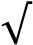 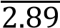 = 1.7
P(X < 0) = 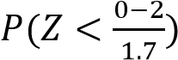= P(Z < - 1.176) = P(X> 1.176)
= 0.5 – P(0 < Z < 1.176)
= 0.5 – 0.3802 = 0.1198
- In a school of 800 students their average weight is 54.5kg and standard deviation 6.8kg. given that the weight of students are normally distributed, find
  - Probability that the weight of any student randomly selected is 52.8 kg or less
Let x be the weight of the student

P(x
≤

52.8) =

(

)
=
P(Z
<
-
0.25)

-
0.25
0 0.25
 | = P(Z> 0.25) = 0.5- P(0 < Z < 0.25) = 0.5 -0.0987 = 0.4013
(ii) | Number of students who weigh over 75kg = 1
P(Z > 75) =

(

)

> 3.01)
P(Z
=

P(Z > 3.01) = 0.5
–

P(0 < Z < 3.01) = 0.5
–

0.4990=

0.001

3.01
0
 | Number of students who weigh more than 75g = 800 x 0.001 =1
(iii) | Weight of the middle 56% of the students

Z
1

0
Z
2

Z

P(X₁ < X < X₂) = P(Z₁< Z < Z₂) = 0.56
But P(0< Z < Z₂) = 2.8; Z₂ = 0.772 and Z₁ = -0.772

Hence the weight range of the middle 56% of students of the school is 49.251< X < 59.750
𝑍

𝑥

-
0.772 =
𝑥

; x
1

= 49.251

𝑍

𝑥

0.772 =
𝑥

; x
2

= 59.750

- A sugar factory sells sugar in bags of mean weight 50kg and standard deviation 2.5kg. given that the weight of the bags is normally distributed, find the
  - Probability that the weight of any bag of sugar randomly selected lies between 51.5kg and
53kg
P(51.5 < X < 53) = 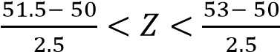= P(0.6 < Z 1.2)
= φ(1.2) – φ(0.6) = 0.3849 – 0.2257== 0.1592
  - Percentage of bags whose weight exceeds 54kg
P(X > 54) =P(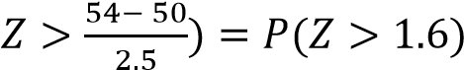= 0.5 –φ(1.6) = 0.5 – 0.4452 = 0.0548
= 0.0548 x 100 = 5.48%
  - Number of bags that will be rejected out of 1000 bags purchased for weighing below 45.0kg
P(X < 45) = P(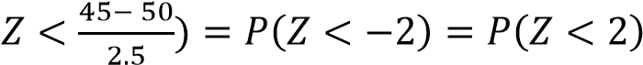= 0.5 –φ(2)= 0.5- 0.4772 = 0.0228
Number of bags rejected = 0.0228 x 1000 = 22.8 23
- A certain maize firm sells maize in bags of mean weight 40kg and standard deviation 2kg, given that the weight of the bags are normally distributed, find
  - Probability that the weight of any bag of maize randomly selected lies between 41.0 and
42.5kg
P(41.0 < X < 42.5) = 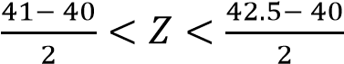= P(0.5 < Z 1.25)
 | = φ(1.25) – φ(0.5) = 0.3944 - 0.1915 = 0.2029
(ii) | Percentage of bags whose weight exceeds 43kg
P(X > 43) =P(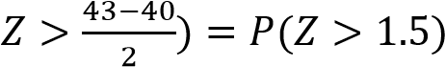= 0.5 –φ(1.5) = 0.5 – 0.4332 = 0.0668
 | = 0.0668 x 100 = 6.68%
(iii) | Number of bags that will be rejected out of 500 bags purchased for weighing below 38.5kg
P(X < 38.5) = P(= 0.5 –φ(0.75)
= 0.5- 0.2734 = 0.2266
Number of bags rejected = 0.2266 x 500 = 113
7. If XN(50, 20). Find
- P(X > 60.3)
P(X > 60.3) = P(Z > 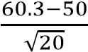) = P(Z > 2.303) = 05 –φ(2.303)
= 0.5 –(0.4893 + 0.0001) = 0.0106
- P(X < 47.3)
P(X < 47.3) P(Z > 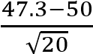) = P(Z <-0.6037) =P(Z> 0.6037) = 05 –φ(0.6037)
= 0.5 –(0.2257 + 0.0013) = 0.273 (iii) P(X > 48.9)
P(X < 48.9) = P(Z > 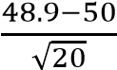) = P(Z <-0.246) = P(Z < 0.246) = 0.5 +φ(0.246)
= 0.5 + 0.0948 + 0.0022 = 0.597
- P(X > 53.5)
P(X > 53.5) = P(Z >
- P(X < 59.8)
P(X < 59.8) = P(Z < 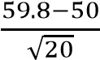) = P(Z < 2.191) = 0.5 + φ(2.191)
= 0.5 + 0.4826 +0.0001 =0.9857
- P(X < 62.3)

P(X < 62.3) = P(Z < 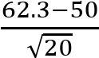) = P(Z < 2.750) = 0.5 + φ(2.730
= 0.5 + 0.4970 = 0.9970
TOPIC 2/2: Differential Equations
Competency: The learner analyses problems involving rates of change for prediction of alterations in various natural and social phenomena over a period of time.

Differential equations (D.Es)
You should have done integration
Definition
These are equations involving differential coefficients (derived functions) like
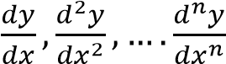.
The order of a differential equation
The order of a differential equation is the order n of which the highest derivative 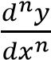 contained in the differential equation. E.g.
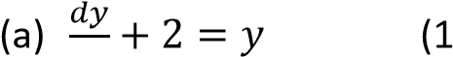st
order D.E) 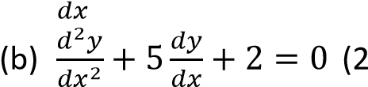nd
order D.E)
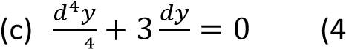 ^{th} order D.E)
Solution to differential equations
This involves the elimination of all the differential coefficients in the given equation. This is normally done by integrating

Example 1
Solve the differential equations
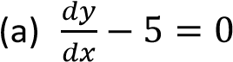
Solution
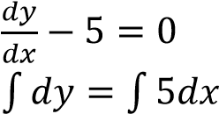
y = 5x +c
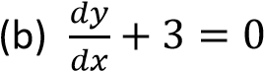
Solution
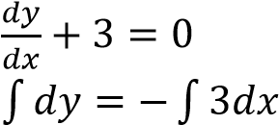
y = -3x +c
Types of solutions of differential equations
There are two types of solutions to differential equations, i.e.
- General solutions remain with arbitrary constant c unsolved, e.g.
Solve 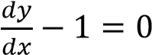
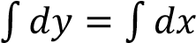
y = x + c (general solution)

- Specific solutions where the arbitrary constant c is eliminated and replaced with specific value, e.g.
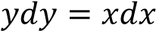, given that y =1 when x = 0
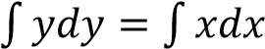
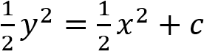
Substituting for x = 0 and y = 1, c =
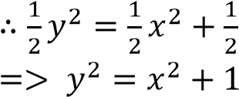(specific solution)

Forming differential equations
This involves forming equations with differential coefficients by eliminating the arbitrary constants.
If the equation has got only one constant of integration, then the differential equation formed will be that of first order.
On the other hand, if the equation has got two constants of integration, the differential equation formed will be that of a second order.

Example 3
Form differential equations from the following equation:
(a) y = x + Solution y = x +
⇨ A = x(y – x)
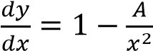
Substituting for A:
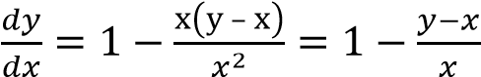
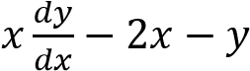 (1st order D.E)
(b) 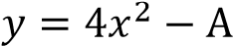
Solution
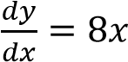
Or
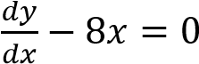

Exercise 1
Form first order differential equations from each of the following equations
(a) y =3x² + Ax 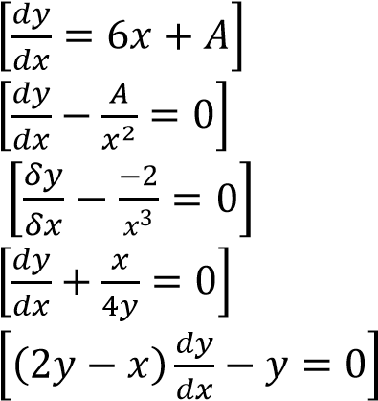
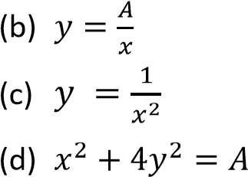
(e) 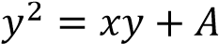

Solving 1st order differential equation
There are three basic methods employed to solve first order differential equations i.e.
- Separable differential equations.
- Differential equations with no separable variables.
These may either be exact or Non-exact
(Inexact)
- Homogenous differential equations.
Separable differential equations
These are solved by separating variables
Suppose that the given differential equation is
in the form of 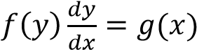, we separate the variables in such a way that 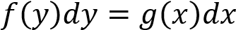.
Then we integrate both sides

Example 4
- Solve the differential equation 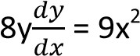
Solution
8ydy = 9x²dx
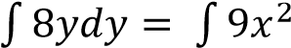dx
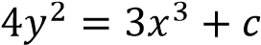
Hence find the solution given that y = 2 when x = 1
Substituting for y = 2 and x = 1 4 x 2² = 3 x 1³ + c c = 16 – 3 = 13
Substituting c in the equation
=> 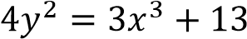
- Solve the differential equation 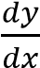= 2x + 5, given that y = -1 when x = 3
Solution dy = (2x +5)dx
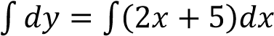
y = x² + 5x + c substituting for y = -1 and x =3 -1 = 9 + 15 + c c = -25
Hence equation: y = x² + 5x - 25
- Solve the differential equation
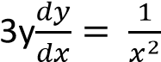 given that y = 2 when x = 1

Solution
3ydy = x⁻²dx
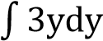 = 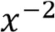dx
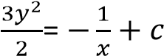……………..(i)
Substituting for y = 2 and x = 1 in equation
(i)
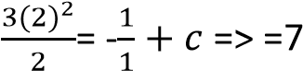
Substituting for c = 7 in equation (i)
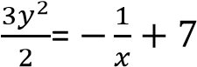
Application of differential equation
A. Rates of decay, decomposition and cooling

Example 5
- The rate of decay of a radioactive material is proportional to the amount x grams of the material present at any time t. Initially there was 60 grams of the material. After 8 years the material reduced to 15 grams.
  - Form a differential equation for the rat of decay of the material. (03marks)
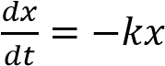
  - Solve the differential equation formed in (a) above. (10 marks)
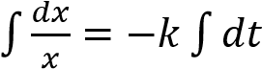
Inx = -kt + c At t = 0, c = In60 t = 8, x = 15
In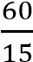= 8k
k =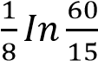= 0.173 year⁻¹
Thus, 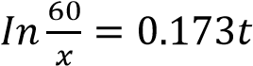
  - Find the time taken for the material to reduce to 10 grams. (02 marks)
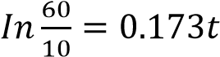
t = 10.36 years
- Chemical A is converted into another chemical by a chemical reaction. The rate at which a chemical A is being converted is directly proportional to the amount present at any time. Initially 100g of chemical A was present. After 5 minutes, 90g of A is present.
  - Form a differential equation for chemical reaction. (03marks)
Let the amount present at time t = x
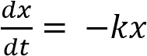
  - By solving the differential equation formed in (a), determine the
    - amount of chemical A present after 20 minutes.
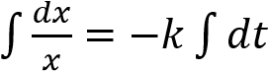
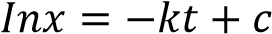
At t =0, x = 100 => c = In100
At t = 5
In90 = -k x 5 + In100
k = 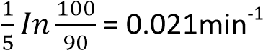
⇨ In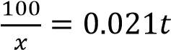
At t = 20
In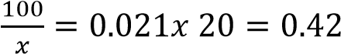

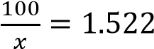 ; = 65.7
Hence the amount present after
20 minutes = 65.7g
    - time taken for the amount of chemical A to be reduced to 20 g (12 marks)
From In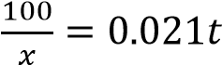
⇨ In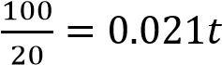
t = 76.64minutes
- The rate of cooling of a body is proportional to the excess temperature above the surrounding air. Given that the surrounding air temperature is 20⁰ C and the body cools from 100⁰C to 60⁰ C in 5 minutes.
  - Determine the temperature of the body after another 20 minutes
  - How long does it take for the body to cool to 30⁰C.
Solution
Let θ be the temperature of the body.
⇨ 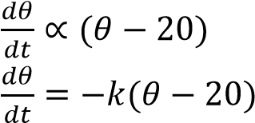

By separating variable
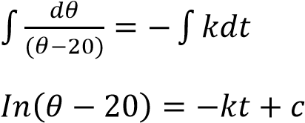
When t = 0, θ = 100 => c = In80
Substituting for c
When t = 5, θ = 60 => In40 = -5k + In80
k = 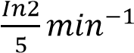
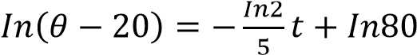
Or
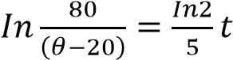
  - After another 20minutes, t = 25
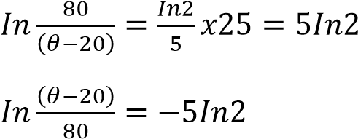
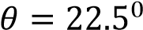
after another 20 minutes the temperature
will be 22.5⁰.
  - When θ = 30⁰C
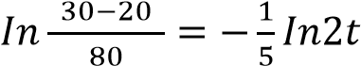
t = 15minutes.
- The rate of cooling of a body is proportional to the temperature of the body at that time. Given that the body cools from 72⁰C to 32⁰C in 10 minutes, determine how much longer it will take the body to cool to 27⁰C.
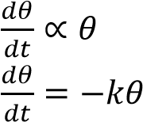
By separating variables
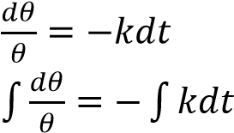
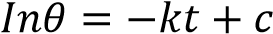
At t = 0, θ = 72⁰C By substitution c = In72
At θ = 32⁰C, t = 10
,
=> k = 0.0811min⁻¹ When θ = 270C

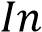 ; t = 12.1min it will take more 12.1 – 10 = 2.1minutes for the temperature to fall to 27⁰C

(v) The rate of decay at any instant of a radioactive substance is proportional to the amount of substance remaining at that instant. If the initial amount of substance is A and the amount remaining after time t is x.
- Prove that 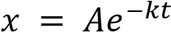, where k is a constant.
- If the amount remaining is reduced
from 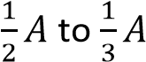 in 8hours, prove that the initial amount of substance was halved in about 13.7hours.
Solution
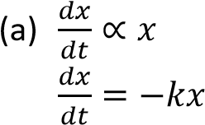
By separating variables
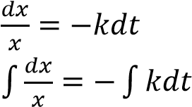
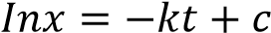
At time t = 0, x = A
By substituting InA = C
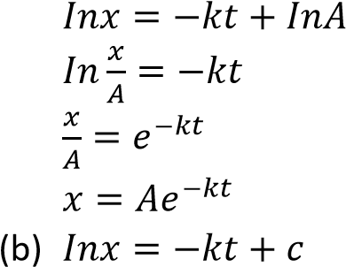
At t = 0, x = 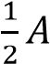; => c = 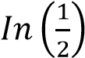
When t = 8, x = 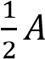;
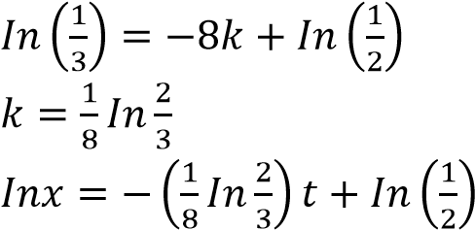
When x is halved to 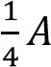
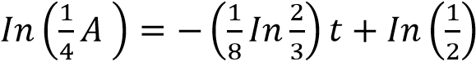
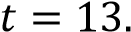676hours  (vi) A substance loses mass at a rate which is proportional to the amount M present at time t.
- Form a differential equation connecting M, t and proportionality constant k.
(02marks)
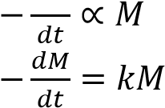
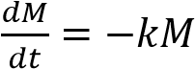

- If the initial mass of the substance is
M₀, show that M = 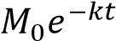. (05marks)

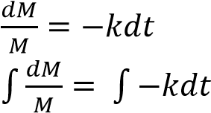
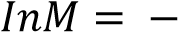kt + C At t= 0; M = M₀ c = InM₀
⇨ kt + InM₀
InM – InM₀ = -kt
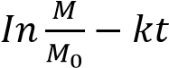 or M = 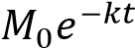
(c) Given that half of the substance is lost in 1600years, determine the number of years 15g of the substance would take to reduce to 13.6g
From 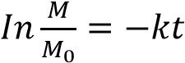
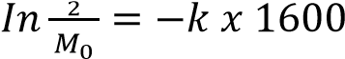
;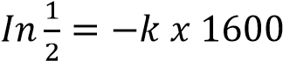
-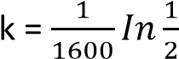
Let the required time be t
In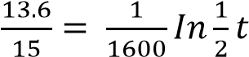
t = 226.17years

Rates of formation, growth and spreading

Example 6
- The rate of growth of a substance is proportional to the original amount. Find the equation of the amount present at any time t.
Solution
Let x be the amount present
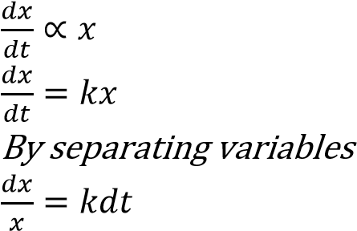
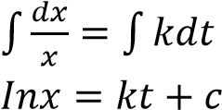
Suppose that at time t = 0, x = x₀(initial amount)
c = In x₀ by substituting for c. 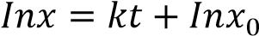
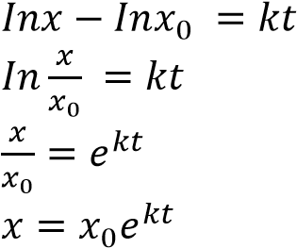
- The rate of growth of population in a country is proportional to the number of people living at that time. In 1980, the population was 18m and in 1990 it was 22m. Estimate
  - The number of population in 2005 Solution
Let P be the amount present
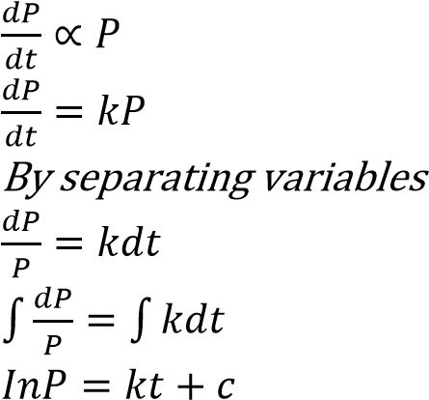
At t = 0 (In 1980), P = 18 => c = In18
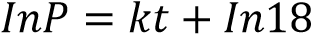
At t = 10 (1990), P = 22
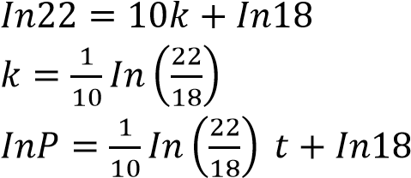
In 2005, t = 25
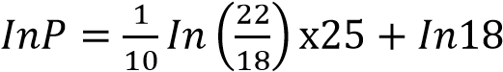
⇨ P = 29.73m
  - How long will it take the population to reach 36m. From
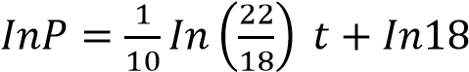
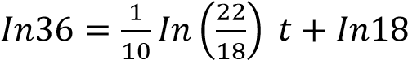 t = 34.54 years
It will take 34.54 years for the population to reach 36m
- The rate at which bush fire spreads is proportional to the unburnt area of the bush. Initially when observation was made, of the bush area had been burnt. Two
hours later, of the bush area had been burnt. Find the fraction of the bush area that will remain unburnt after 5 hours.
Solution
Let the fraction of unbush area be x
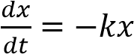
(-ve because the unburnt area decreases with time
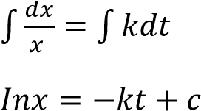
At t = 0, x =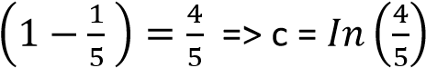
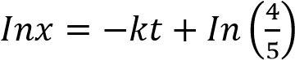
At t = 2, x =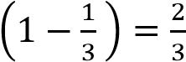
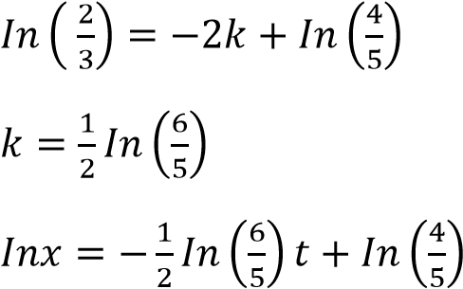
At t = 5
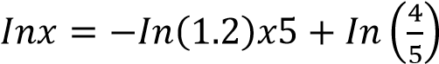
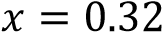
The fraction remaining after 5hours is 0.32

Linear motion Example 7
(a) A body of mass m is projected upwards with initial velocity u. Given that it experiences a resistance proportional to the velocity, v on its upward path, determine the
(i) Velocity v after time t, (ii) Displacement, s, after time t. (iii) Limiting speed of the body.

Solution

Resistance, R = kv

Direction

of motion

mg

Resistance

Using Newton’s 2nd law of motion
(i) Resultant force 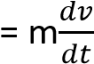
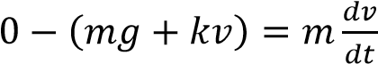
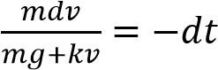
⇨ 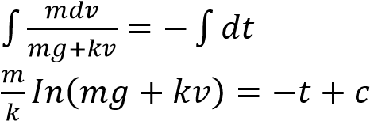

Initially (t = 0), v = v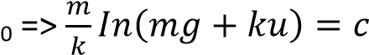
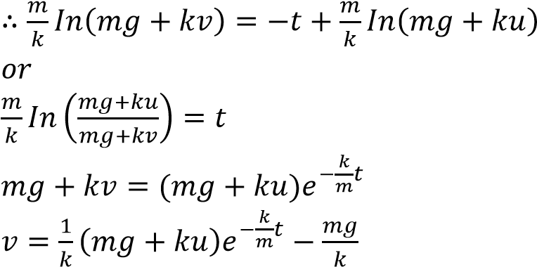

(ii) 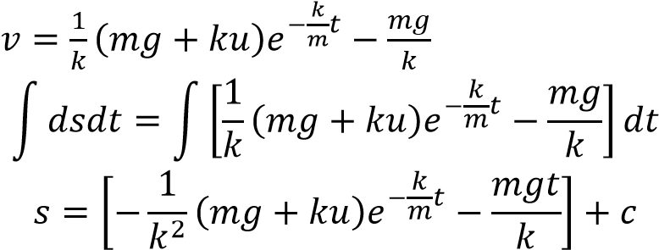

At t = 0, s = 0
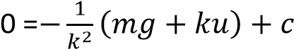
c = 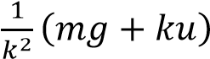
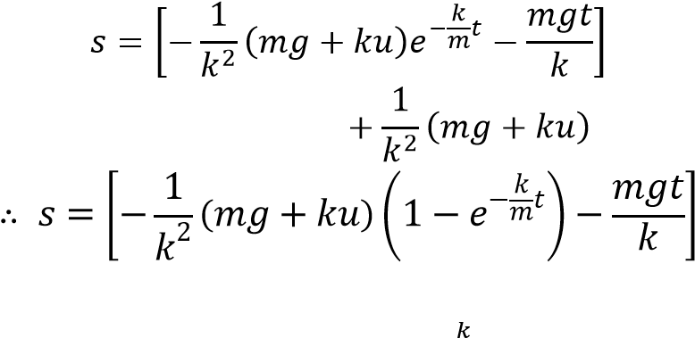
(iii) From 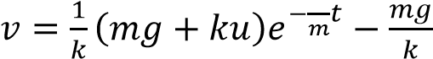
As t →ꚙ, 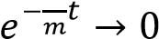
limiting velocity =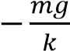
- The rate of change of atmospheric pressure P with respect to altitude, h in kilometres is proportional to the pressure. If the pressure at 2km is ¼ of the pressure P₀ at sea level. Find the formula for the pressure at any height. Solution
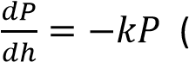-ve because pressure decreases with altitude) Separation of variables
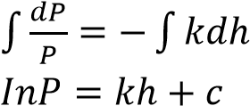
At sea level (h = 0), p = P₀ => c = InP₀
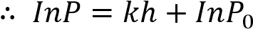
When h = 2km, P = 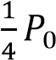
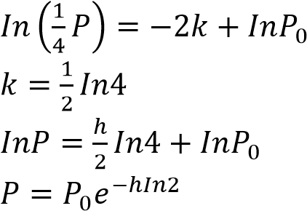
- The differential equation 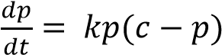 shows the rate at which information flows in a student population c. p represents the number who have heard the information in t days and k is a constant.
- Solve the differential equation.
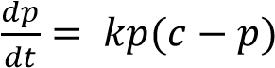
Separating variables
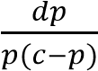= kdt
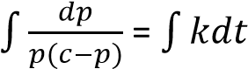
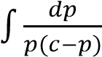= kt + a where a is a constant
By partial fractions
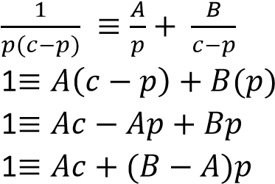
Equating constants
1 =Ac
A =
Equating coefficient of p
0 = B – A = B =
⇨  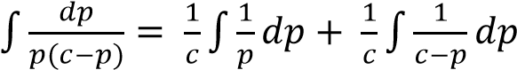
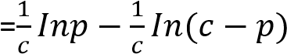
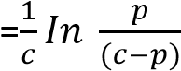
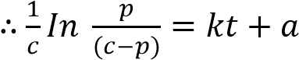

- A school has a population of 1000 students. Initially 20 students had heard the information. A day later, 50 students had heard the information. How many students heard the information by the tenth day?

Solution
Given c =1000, at t=0, p= 20
By substitution, we have
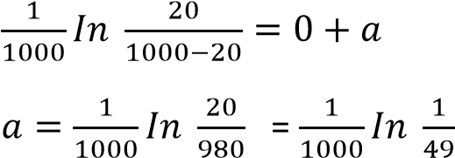
- 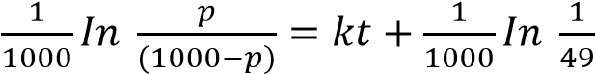
After t = 1, p = 50; by substitution, we have
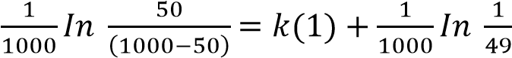
k =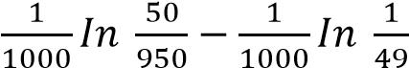
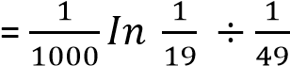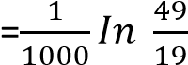
- 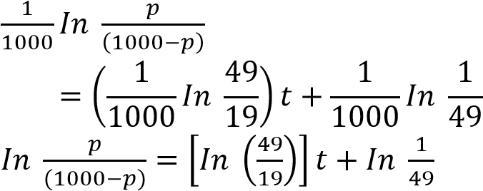

Note: by 10th day is the same as after 9 days
Substituting for t = 9
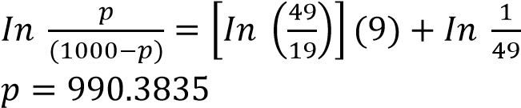
Number of students who heard the
information by the 10th day is 990

Exercise 5
- The rate, cm³s⁻¹, at which air is escaping from a balloon at time t seconds, is proportional to the volume of air, Vcm³ in the balloon at the instant. Initial volume is 1000cm³.
  - Show that V = 1000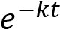, where k is a positive constant.
  - Given that V = 500cm³ when t = 6; show that k = 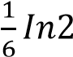.
  - Calculate the value of V when t = 12s.
[250 cm³]
- At time t minutes the rate of cooling of a liquid is proportional to the temperature, T⁰C of the liquid at that time. Initially T = 80
  - Show that T = 80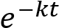, where k is a positive constant.
  - Given that T = 20 when t = 6; show that k = 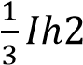.
  - Calculate the time at which the temperature will reach 10⁰C. [9]
- The value of a certain product depreciates in such a way that when it is t years old, the rate of decrease in value is proportional to the value, x, of the product at that time.
The product costs 12000 when new.
  - Show that x = 12000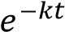
  - Given that after 3 years the value dropped to 400;
    - show that k = 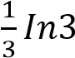.
    - Calculate to the nearest month, the time taken for the value to drop to
2000. [4years 11mnths]
- A lump of a radioactive substance is decaying is proportional to the mass M in
grams at time t. Initially M = 72 and decreases to 50 in 2 hours. Show that
M = 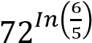.
- The rate at which a bacteria is reduced by a chemical is proportional to the number of bacterial present. Given that the population of the bacteria is reduced to half in six days; show that the population will be reduced to 1% of the original population in about 40days.

Topical revision exercise
1. Solve the equations
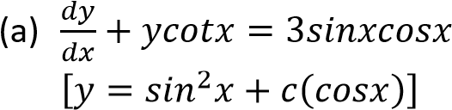
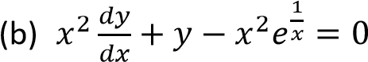; given y = 2
when x = 0 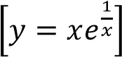
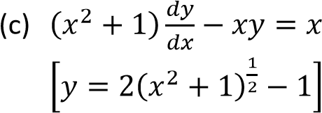; x = 0, y = 1.

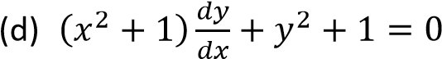;
x = 0, y = 1.
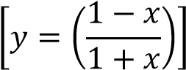
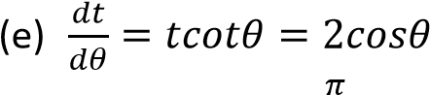;
t = 3 when θ =
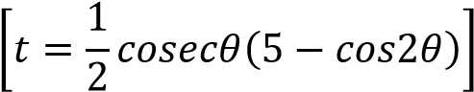
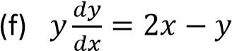(use substitution y
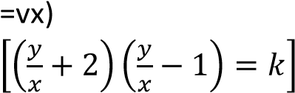

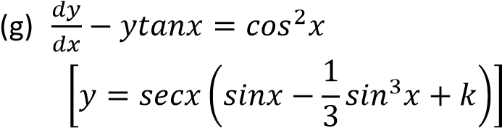
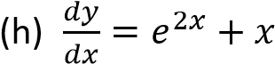 give R(0) = 3
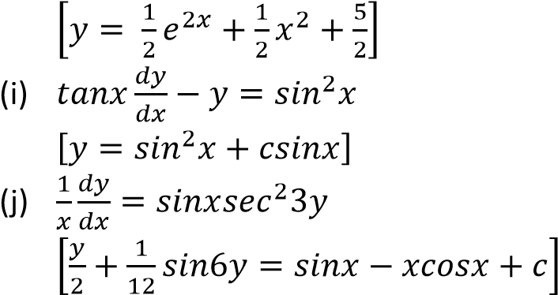
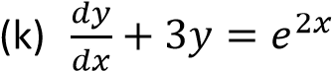;z x=0, y= 1
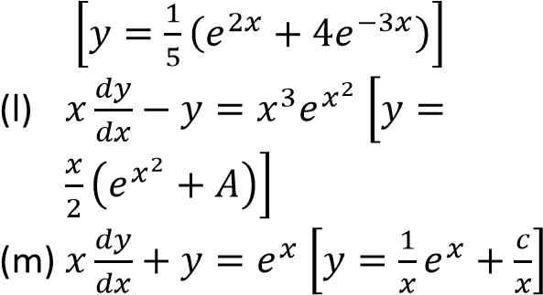
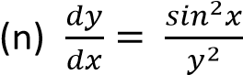; x = 0, y = 1
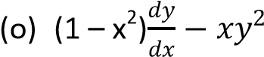=0, y = 1 when x =
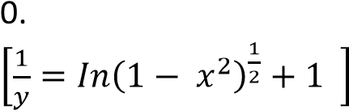
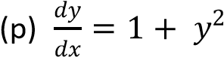; y = 1 when x = 0.
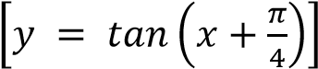

2. The rate of cooling of a body is proportional to the difference θ between the temperature of the body and that of the surrounding air.
- Write down a differential equation involving θ for this process
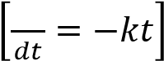
- If the surrounding air temperature is stable at 20⁰C and the body cools from 80⁰C to 70⁰C in 5 minutes; find the temperature after 15minutes [54.72⁰C
- A metallic teapot losses heat due to a steady breeze at a rate proportional to its temperature θ and gains temperature from a directed beam at a rate proportional to time t. Show that
at any time t, 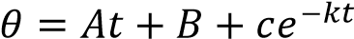
- The rate of change of atmospheric pressure, p, with respect to altitude, h, in km is proportional to pressure. If the pressure at 6000m is half the pressure P0 at sea level. Find the formula for the pressure at any height
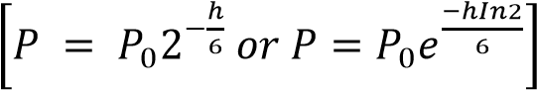
- The mass of a man together with his parachute is 70kg. when the parachute is fully open, the system experiences an upward force proportional to the velocity of the system. If the constant of proportionality is 1/10 when the system is descending at 10 ms⁻¹, determine the speed of the parachute three minutes later [7.74ms⁻¹ ]
- A vessel in a shape of an inverted right circular cone contains a liquid. The rate of evaporation of the liquid is proportional to the surface exposed to the atmosphere. The radius of the base of the cone is 9cm and the height of the cone is 15cm. if it takes 1 minute for the radius of the surface of the liquid to decrease from 9cm to 4.5cm, how long will it take for the liquid to evaporate completely. [6.88minute]
- A rumour spreads through town at a rate which is proportional to the product of the number of the people who have heard it and that of those who have not heard. Given that x is the fraction of the population who have heard the rumour after time t.
    - Form a differential equation connecting x, t and constant k.
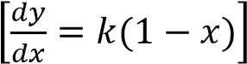
    - If initially a fraction C of the population had heard the rumour,
deduce that 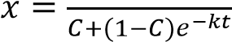
    - Given that 15% had heard the rumour at 9.00am and another 15% by noon, find what fraction of the population would have heard the rumour by 3.00pm [0.21]
- A research to investigate the effect of a certain chemical on a crop virus infection revealed that the rate at which the virus population is destroyed is directly proportional to the population at that time. Initially the population was P₀ at time t months later, it was found to be P.
    - Form a differential equation connecting P and t.
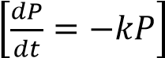
    - Given that the virus population reduced to one third of the initial population in 4 months, solve the equations in (a)
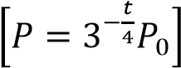
    - Find
    - How long it will take for 5% of the original population to remain.
[10.907months]
    - What percentage of the original virus population will be left after 2
½ months.[50.33%]
- In a culture of bacteria, the rate of growth is proportional to the population present at time t. the population doubles every day. Given that the initial population P₀ is one million, determine the day when the population will be 100 million.[7th day]
- (i) The volume of a water reservoir is generated by rotating the curve y =kx² about the y-axis. Show that when the central depth of the water in the reservoir is h meters, the surface area, A is proportional to h and the volume is proportional to h².
    - If the rate of loss of water from the reservoir due to evaporation is λA m² per day, obtain a differential equation for h per day.
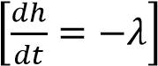
    - Given that λ = ½, determine how long it will take for the depth of water to decrease from 20m to 2m
[36days]
- The acceleration of a particle after time t seconds is given by α = 5 + cos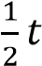. If initially the particle was moving at 1 ms1, find its velocity after 2π second and the distance it would have covered by then.
- An athlete runs at a speed proportional to square root of the distance he still has to cover. If the athlete starts running at 10ms⁻¹ and has a distance of 1600m to cover, find how long he will take to cover the distance. [320s]
- A hot body at a temperature of 100⁰C is placed in a room of temperature 20⁰C. Ten minutes later, its temperature is 60⁰C. determine the temperature of the body after another 10 minutes. [40⁰C]
- The number of car accidents x in a year on a highway was found to approximate the differential equation 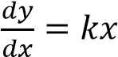,
where t is time in years and k is a constant. At the beginning of 2000 the number of recorded accidents is 50. If the number of accidents increased to 60 at at the beginning of 2002, estimate the number that was expected at the beginning of 2005. [79]
- In a certain process the rate of production of yeast is kx grams per minute, where x gram is the amount produced and k= 0.003.
    - Show that the amount of yeast is doubled in in about 230 minutes
    - If in addition yeast is removed at a constant rate of m grams per minute, find the
(i) Amount of yeast at time, t minutes, given that when t = 0;
x = p grams
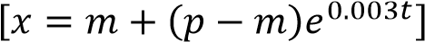
(ii) Value of m if p =20,000g and the supply of yeast is exhausted in 100minutes. [77166g]
- Bacteria in a culture increase at a rate proportional to the number of bacteria present. If the number increases from 1000 to 2000 in an hour,
    - Find how many bacteria will be present after 1 ½ hour. [2829]
    - How long will it take for the number of bacteria in the culture to become
4000? [2hours]
- It is observed that the rate at which a body cools is proportional to the amount by which its temperature exceeds that of its surroundings. A body at 78⁰C is placed in a room at 20⁰C and after 5 minutes the body had cooled to 65⁰C. what will be its temperature after further 5minutes.
- At 3.00pm, the temperature of a hot metal was 80⁰C and that of the surrounding was 20⁰C. At 3.03 ppm the temperature of the metal had dropped to 42⁰C. The rate of cooling of the metal was directly proportional to the difference between its temperature θ and that of the surroundings. Find the temperature of the metal at 3.05pm.
[31.27⁰C]
- Solve the differential equation
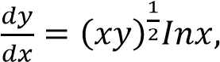 given that y = 1 when x
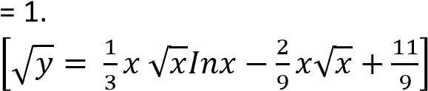
Hence find the value of y when x = 4
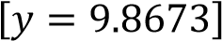
- The rate at which the temperature of a body falls is proportional to the difference between the temperature of the body and that of its surrounding. The temperature of the body is initially 60⁰C. After 15 minutes the temperature of the body is 50⁰C. The temperature of the surrounding is 10⁰C.
(a) Form a differential equation for the temperature of the body. (09marks)
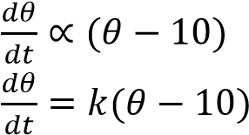
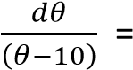-kdt
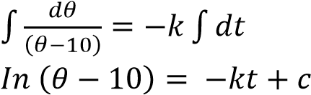
When t = 0, θ = 60
c = 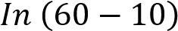 =In50
when t = 15, θ = 50
15k = In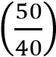 k = 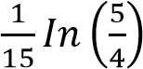
Hence the differential equation is
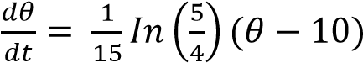

(b) Determine the time it takes for the temperature of the body to reach 30⁰C. (03marks)
In (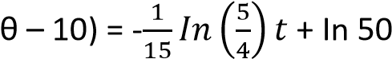
When t = T and θ = 30
-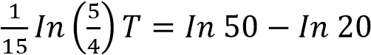
T = 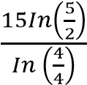= 61.5943minutes
- Solve the differential equation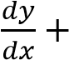
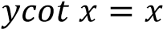, given that y = 1 when x = . (08marks)
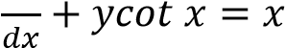
Integrating factor,
I.F = 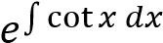
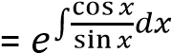
= 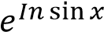 = sinx
Multiplying all terms by integrating factor
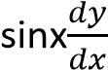+ ycotxsinx = xsinx 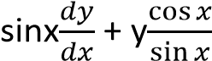sinx = xsinx
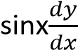+ ycosx = xsinx
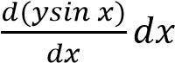= xsinx
Integrating with respect to x
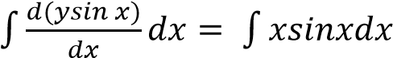
Ysin x = 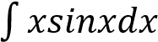
Let u = x, 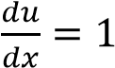
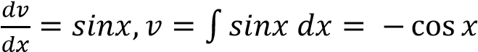
Using integration by parts on RHS
ysinx = -xcosx + 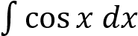
ysinx = -xcosx + sin x + c
But y = 1, x =
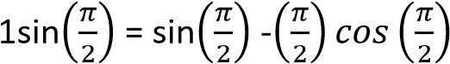+C
C = 0
By substitution, ysinx = sinx - xcosx

